**Hotel Management System Entity Relationship Diagram**

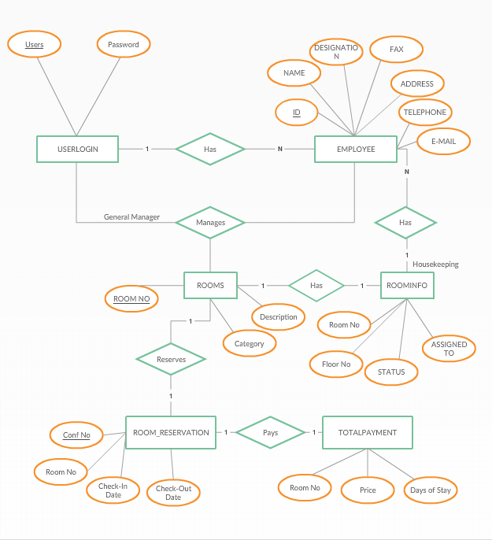

**Hotel Management System Entity Relationship Diagram**

